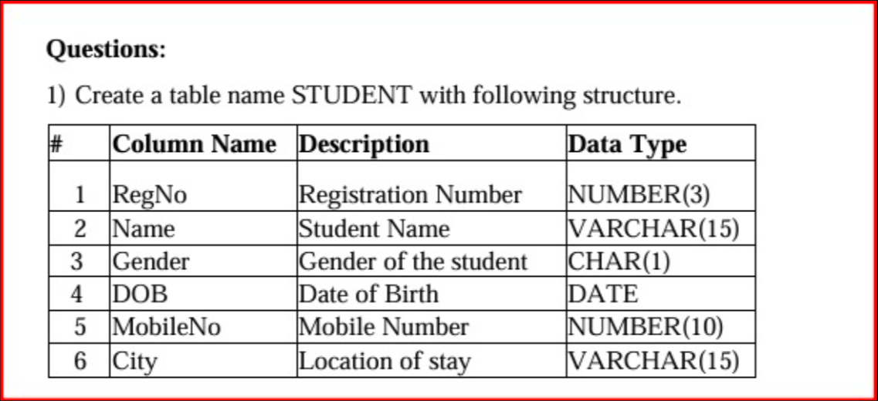

Command:

CREATE TABLE student (
RegNo NUMBER(3),
Name VARCHAR(15),
Gender CHAR(1),
DOB DATE,
MobileNo NUMBER(10),
City VARCHAR(15)
);

DESCRIBE student

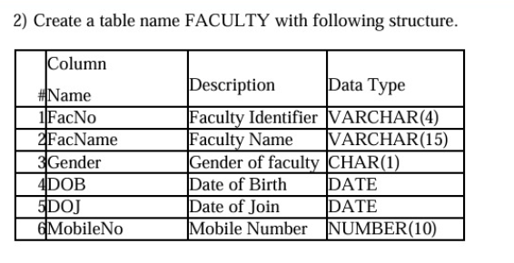

Command:
CREATE TABLE faculty (
FacNo VARCHAR(4),
FacName VARCHAR(15),
Gender CHAR(1),
DOB DATE,
DOJ DATE,
MobileNo NUMBER(10),
);

DESCRIBE faculty

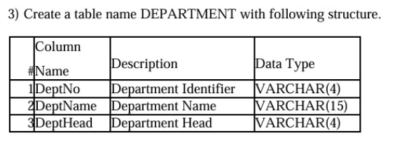

Command:
CREATE TABLE department (
DeptNo VARCHAR(4),
DeptName VARCHAR(15),
DeptHead VARCHAR(4),

);

DESCRIBE department

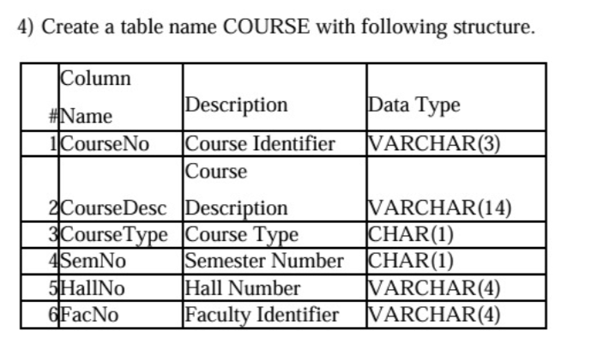

Command:

CREATE TABLE course (
CourseNo VARCHAR(3),
CourseDesc VARCHAR(14),
CourseType CHAR(1),
SemNo CHAR(1),
HallNo VARCHAR(4),
FacNo VARCHAR(4),

);

DESCRIBE course

Command:

ALTER TABLE FACULTY
ADD Dept VARCHAR2(10);

DESCRIBE faculty

